Unit 23 – Multi camera production
Unit Evaluation
Roles for my team:
Camera 1 (Safety Camera): Harry Buckberry (Bottom)
Camera 2: Alex Butler (Left)
Camera 3: Matt Errington (Right)
Vision Mixer: Sam Thomas
Director: Phelisa Mfazwe

Team Discussion & Floor Plan
When deciding our roles, we took into account what experience we all had and discussed who would best suit each role. When we had made our decisions, we all felt comfortable with the job we had be given, which I find is a very important factor to deal within when filming in a team as most people tend not to communicate their difficulties with each other, so making sure everybody was happy in their position helped assure each member that we were all capable of working independently during the performance. Before the performance, we had plenty of time to plan out how we were going to film, for example, at the start of each song the vision mixer had to avoid using camera 3 until it was set up correctly. This is because cam 3 had to be adjusted depending on whether the song contained a pianist, if it didn’t, the camera had to be moved to face the orchestra or stage. All three cameras were set up hours prior to the event and were all connected to the vision mixing station via multiple cables and conversion boxes.
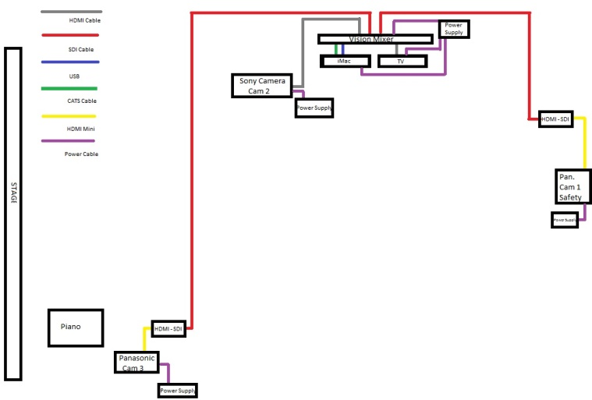

Filming the performances & Risk Assessment
During the filming of our first performance – the barbershop quartet, we had to quickly re-shuffle the arrangement of the third camera to make it face the stage. Because of this, the vision mixer did not swap to that particular camera until a few seconds into the performance, after it had been adjusted. Due to the pace of the song, the director and vision mixer chose to use fades as their transitions. These transitions reflect the low levels of tension given off by the performers. One of the main problems with the filming was the fact that camera 3 was slowly zooming in and out and therefore loosing focus constantly, making the video appear amateurish. This is my fault, as I was the one doing this. My reasoning behind my actions were that I assumed that the auto-focus was better than it was, and I also felt that the performance could have benefited from a slight amount of movement (With the plan that the vision mixer would only cut to Cam 3 during a zoom in). I communicated my intensions with my team hours before the event took place and nobody raised any alarm bells, although I found out afterwards that our teacher had advised against this in a Facebook post. Mistakes were made on my part that affected the overall quality in a negative way, I’m happy to admit that, but I have at least learned from them, which will better prepare me for future performances that may arise. During all our filmed performances, we make it clear that each camera operator was to remain seated until the intermission, this is to avoid having people walk around in the dark, risking tripping on a loose cable. All team members knew where the fire exits were and that they should not block them with equipment like tripods, cameras and bags.

